

**SERVICE NOW : LAPTOP SERVICE REQUEST CATALOG ITEM**

**A PROJECT REPORT**

***Submitted by***

|  |  |
| --- | --- |
| **NAME** | **Naan mudhalvan Id** |
| **ABDUL BASITH M F** | **Asunm1439222308120** |
| **ILAYARAJA T** | **Asunm1439222308126** |
| **MANOFRANCIES A** | **Asunm1439222308130** |
| **k SHEERIN NISHA** | **Asunm1439222308156** |

**In partial fulfillment for the award of the degree**

**of**

**BACHELOR OF SCIENCE**

**IN**

**COMPUTER SCIENCE**

**SHREE CHANDRAPRABHU JAIN COLLEGE**

**MINJUR**

**SEP 2025**

**SERVICE NOW**: **Laptop service request catalog Item**

**(service now project report )**

**Introduction:**

The Laptop Service Request Catalog Item project is designed to simplify how employees can request laptops through the ServiceNow Service Catalog. This project focuses on building a self-service portal item where users can submit requests by filling in essential details like laptop model, justification

**Description:**

This project provides a service catalog item inside ServiceNow for requesting laptops. Users can choose a laptop model, add justification, and optionally request accessories. The request will be submitted to the ServiceNow system,

* where it can be tracked with a unique request number.
* The project covers the end-to-end workflow
* Creating an update set
* Building the catalog item
* Adding variables for input
* Applying Ul policies and UI actions
* Exporting and importing the update set
* Testing the item in the Service Portal

**Scenario based introduction:**

Imagine an employee joining a new company. Instead of sending emails or making manual requests, the employee can simply go to the Service Portal and choose the Laptop Request option. By filling in details such as model and accessories, the request is automatically submitted and tracked in the system, making the process fast and transparent.

**Technical Architecture:**

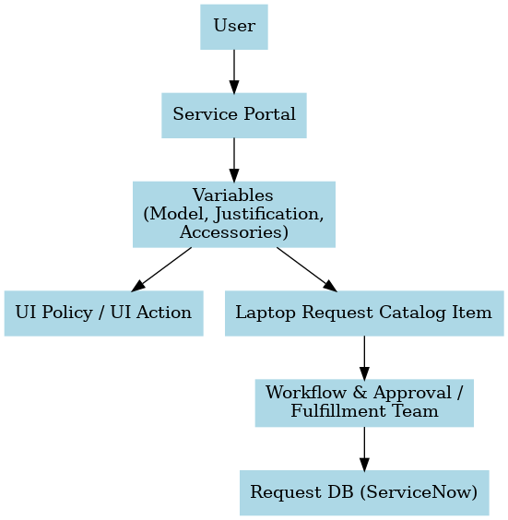

The technical workflow includes:

* Service Catalog Item in ServiceNow → Frontend form for users.
* Variables → Capture user inputs (Laptop Model, Justification, Accessories).
* UI Policy / UI Action → Customize behavior (mandatory fields, extra buttons).
* Workflow / Fulfillment → Route the request for approval or fulfillment.
* Update Set → Capture and migrate all changes.

**Project Goals and Objectives:**

The primary goal of the Laptop Service Request Catalog Item project is to simplify and automate laptop request management in ServiceNow.

Our objectives include:

* **Automated Process**: To automate the process of laptop requests and reduce manual work.
* **Self-Service Portal**: To provide a user-friendly self-service catalog item for employees to request laptops easily.
* **Request Tracking**: To track all requests using unique request numbers in ServiceNow, ensuring transparency.
* **Practical Understanding**: To understand and implement UI Policies, UI Actions, and Update Sets in real-time scenarios.

**Features of Laptop Service Request Catalog Item**

The Laptop Request Catalog Item in ServiceNow provides the following features:

* **Laptop Model Selection** : Users can specify the preferred laptop model they need.
* **Justification Field :** A text area where users provide the reason for requesting a laptop.
* **Additional Accessories** : Options to request accessories such as Mouse, Keyboard, or Laptop Bag.
* **Dynamic Form Behavior** : UI Policies and UI Actions control the visibility and mandatory status of fields based on user inputs.
* **Request Number Generation** : Each submitted request generates a unique request number (REQ), enabling easy tracking.
* **Workflow Integration :** The request is automatically routed to the approval and fulfillment team.
* **Update Set Support** : All configurations are captured in update sets, allowing migration to other instances.

**Project Flow:**

The development of the Laptop Service Request Catalog Item was carried out in a series of well-defined milestones, ensuring that each step of the process was properly implemented, tested, and validated.

**Milestone 1**: Update Set Creation

* The project began with the creation of a Local Update Set in ServiceNow.
* This step was very important as it ensured that every configuration, customization, and development made in the instance would be tracked.
* The Update Set was marked as current, so all subsequent changes were automatically captured.

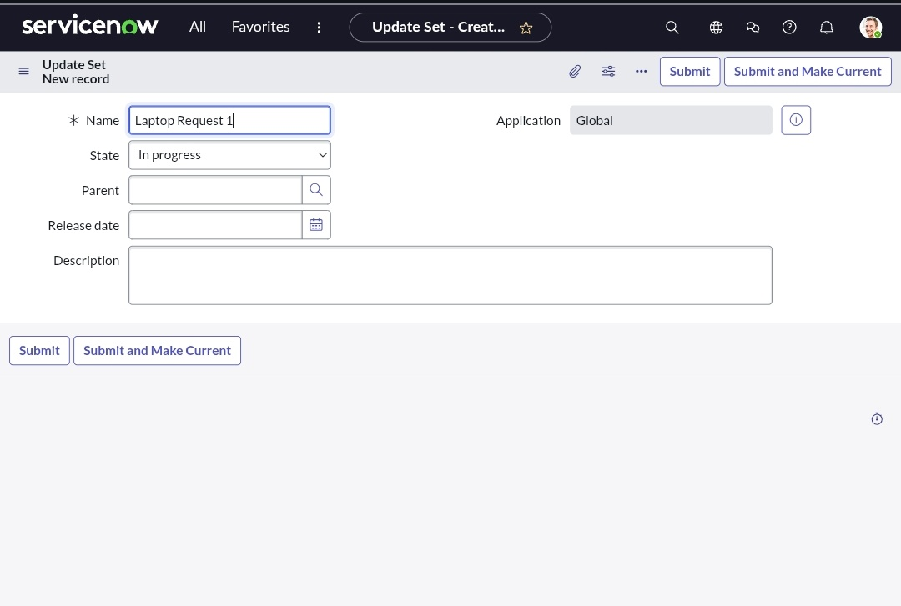

**Milestone 2**: Service Catalog Item Development

* A new Service Catalog Item named Laptop Request was created under the Hardware category.

**Several variables were added to collect input from users, such as:**

* Laptop Model – to specify the required laptop brand/model.
* Justification – to provide the reason for requesting a laptop.
* Additional Accessories – to allow employees to request extra items like a keyboard, mouse, or bag.

This formed the frontend request form that employees would use in the Service Portal.

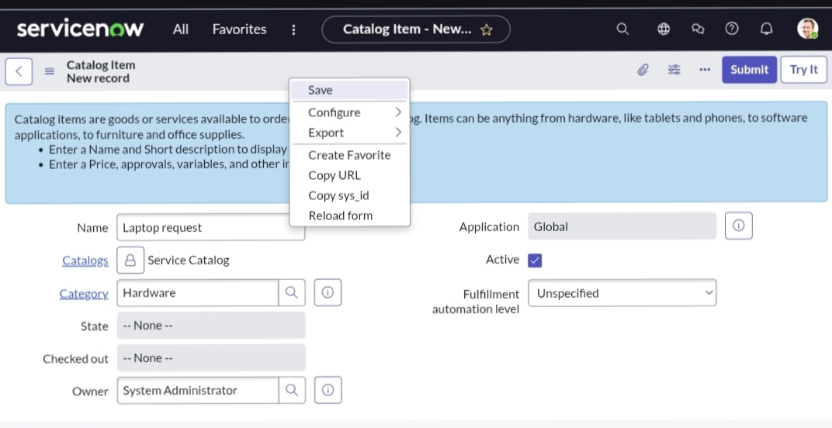

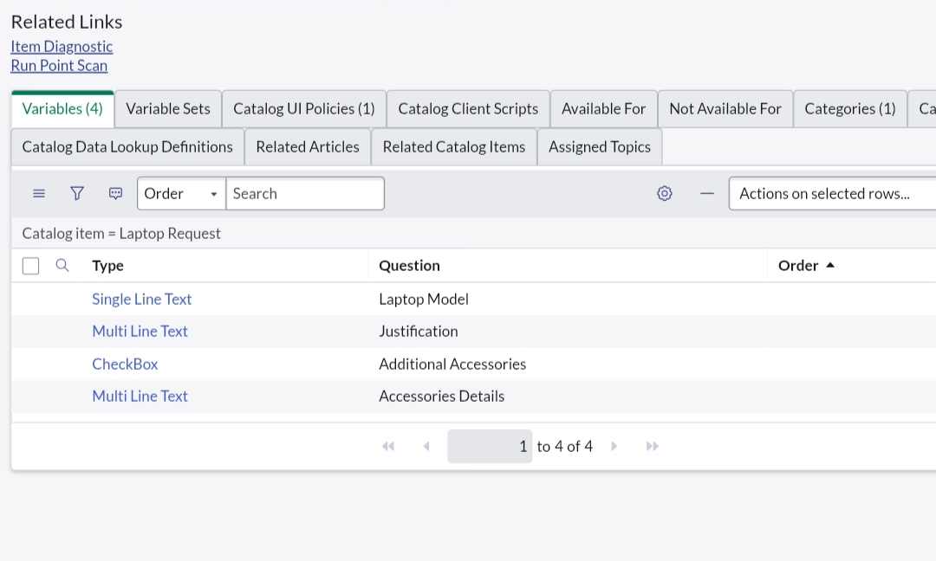

**Milestone 3**: UI Policy and UI Action Configuration

* UI Policies were created to manage dynamic behavior of the form. For example:
* Making justification a mandatory field.
* Displaying accessories details field only when the “Additional Accessories” option was selected.

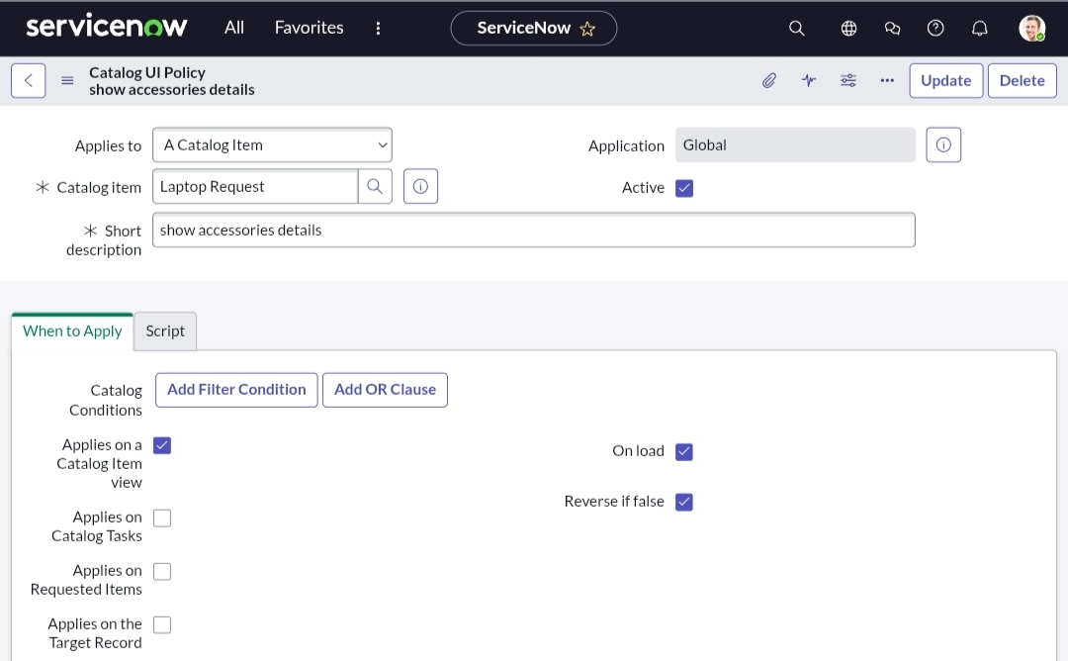

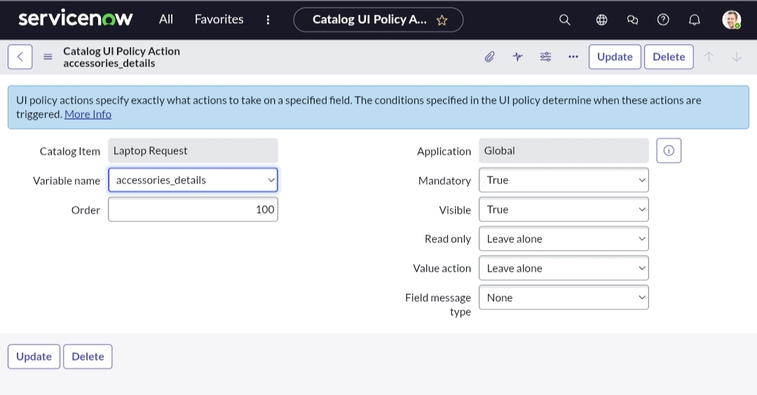

* UI Actions were created to add extra functionality, such as customizing the Order Now button and improving the request submission process

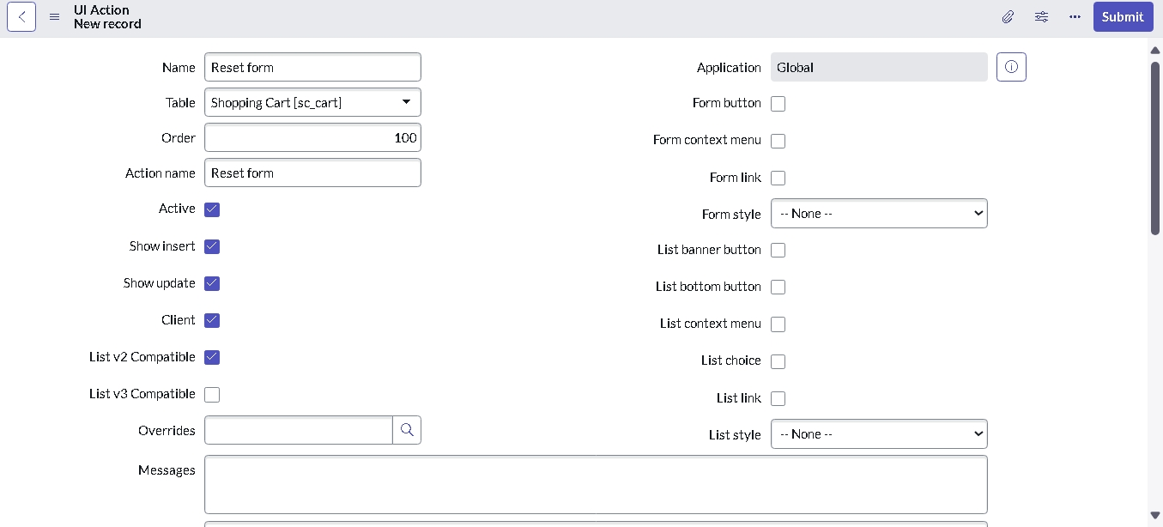

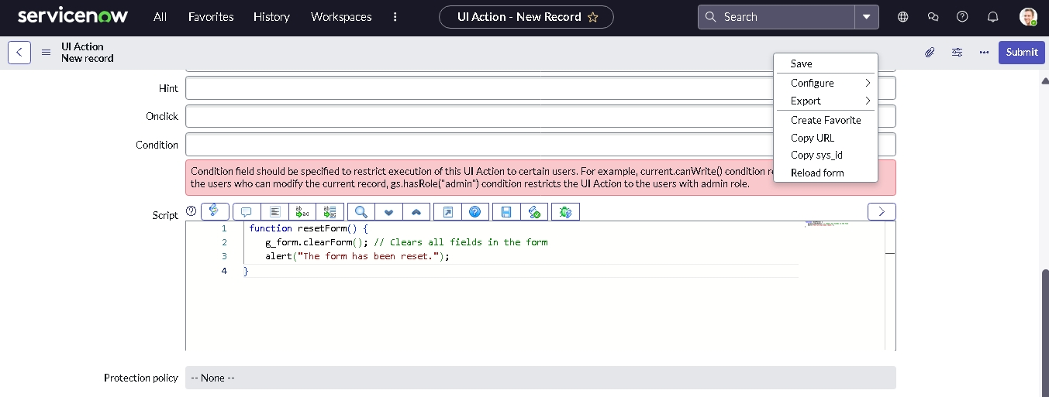

**Milestone 4**: Update Set Migration

The migration of the Laptop Request Catalog Item was carried out using the Update Set feature in ServiceNow. The steps included:

1. **Export Update Set to XML**

* After completing development, the Update Set was marked as Complete.
* From the Related Links section, the update set was exported as an XML file.

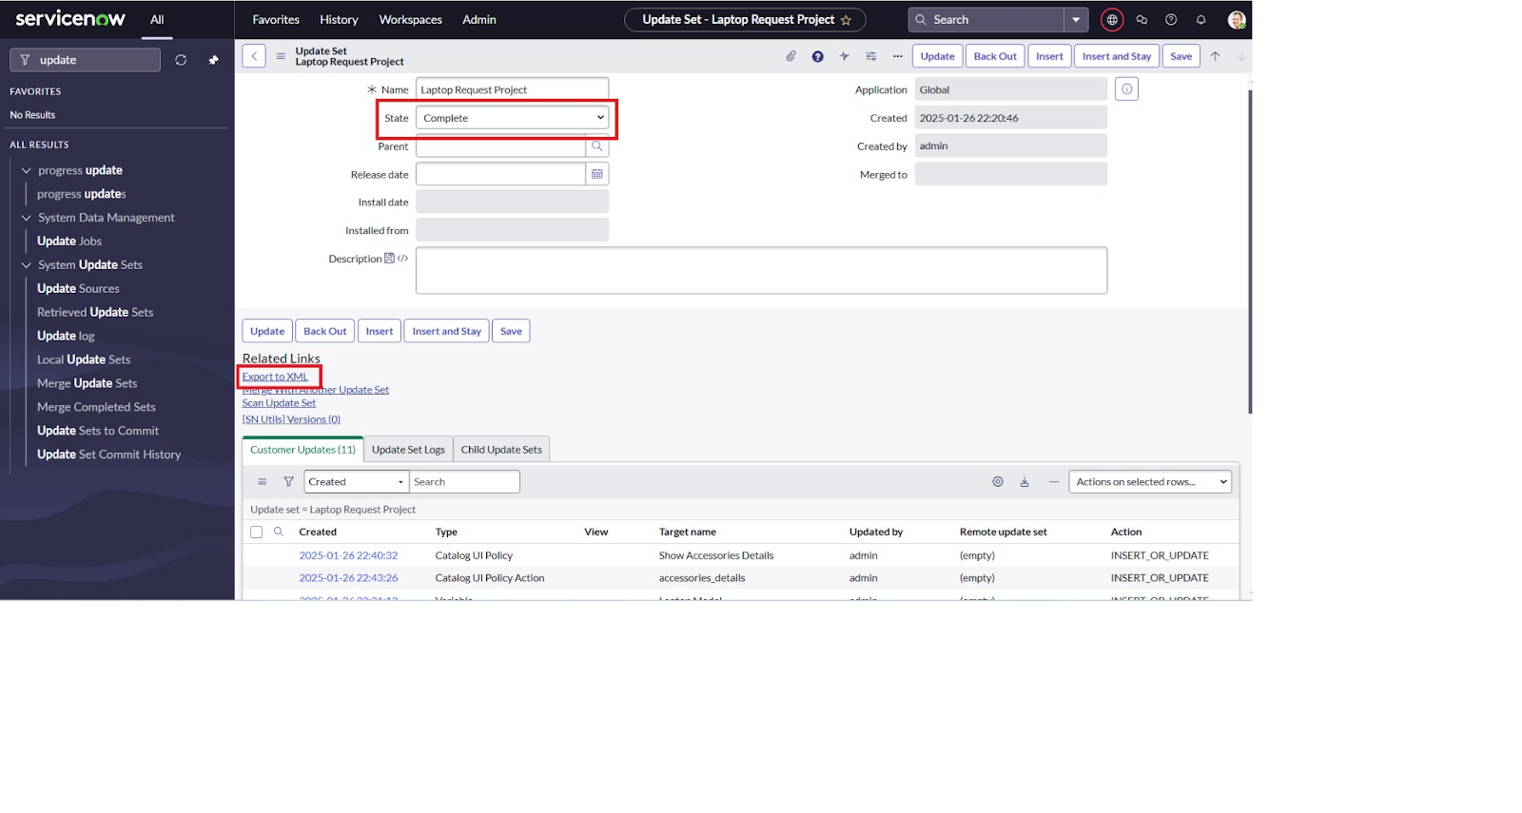

**2. Retrieved Update Set**

* In the target ServiceNow instance, navigation was done to Retrieved Update Sets.
* Here, the option Import Update Set from XML was selected.

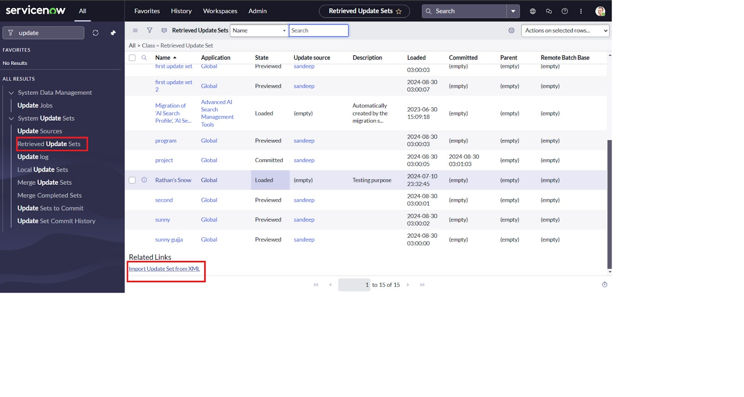

**3. Upload XML File**

* The exported XML file was chosen and uploaded into the new instance.
* Once uploaded, the update set appeared in the list of retrieved update sets.

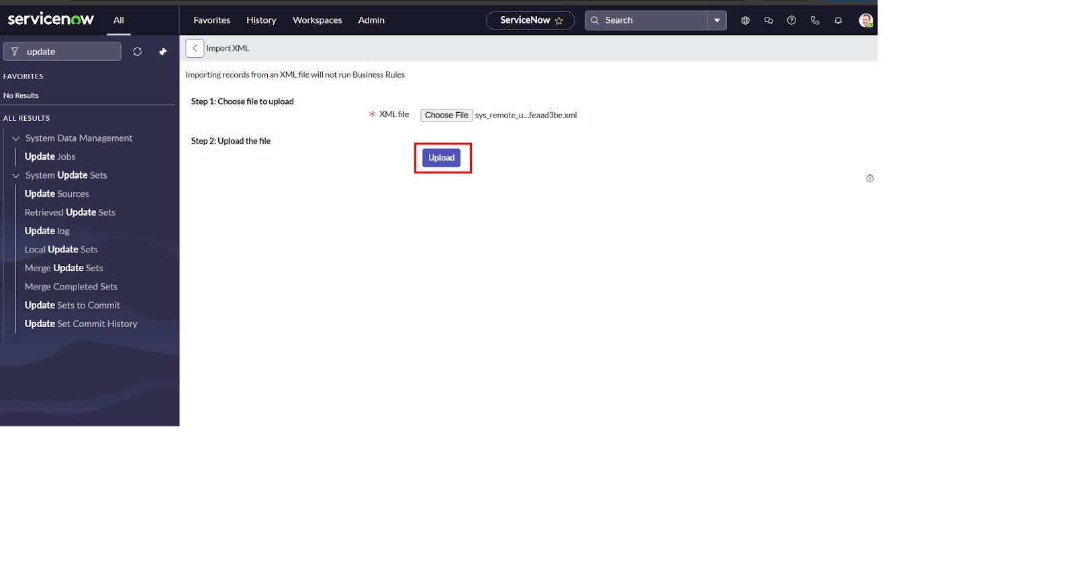

**4. Preview Update Set**

* The retrieved update set was previewed to check for errors, conflicts, or missing dependencies.

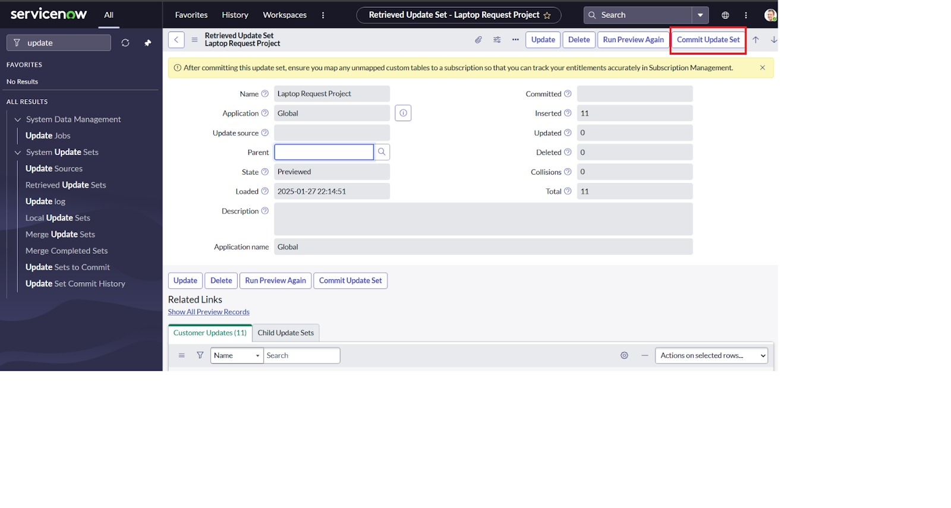

**5. Commit Update Set**

* After successful validation, the update set was committed.
* This applied all the changes (Catalog Item, Variables, UI Policies, and UI Actions) into the target instance.

**Milestone 5**: Testing and Validation

The final stage involved testing the Laptop Request Catalog Item from the Service Portal.

* The form was opened, and test data was entered (Laptop Model = Dell, Justification = “Need for project work”, Accessories = Keyboard).
* The request was submitted successfully, generating a unique Request Number (REQ).
* The request followed the designed workflow and moved through approval and fulfillment stages.
* This validated that the catalog item, variables, UI policies, UI actions, and workflow were working as intended

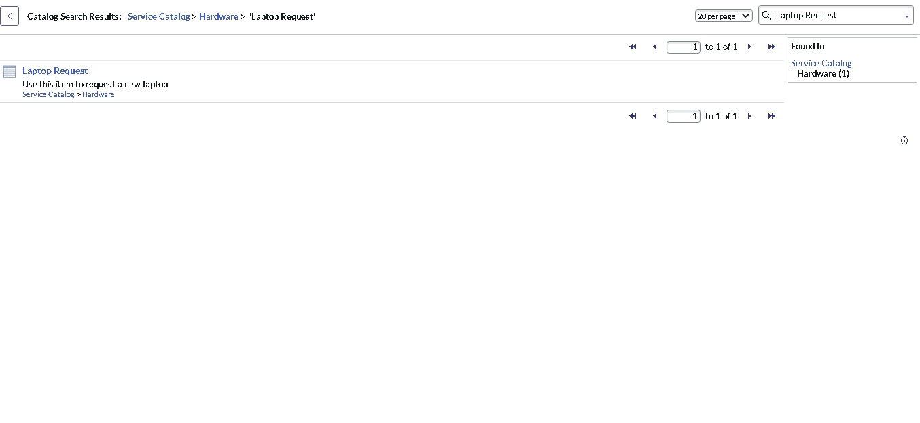

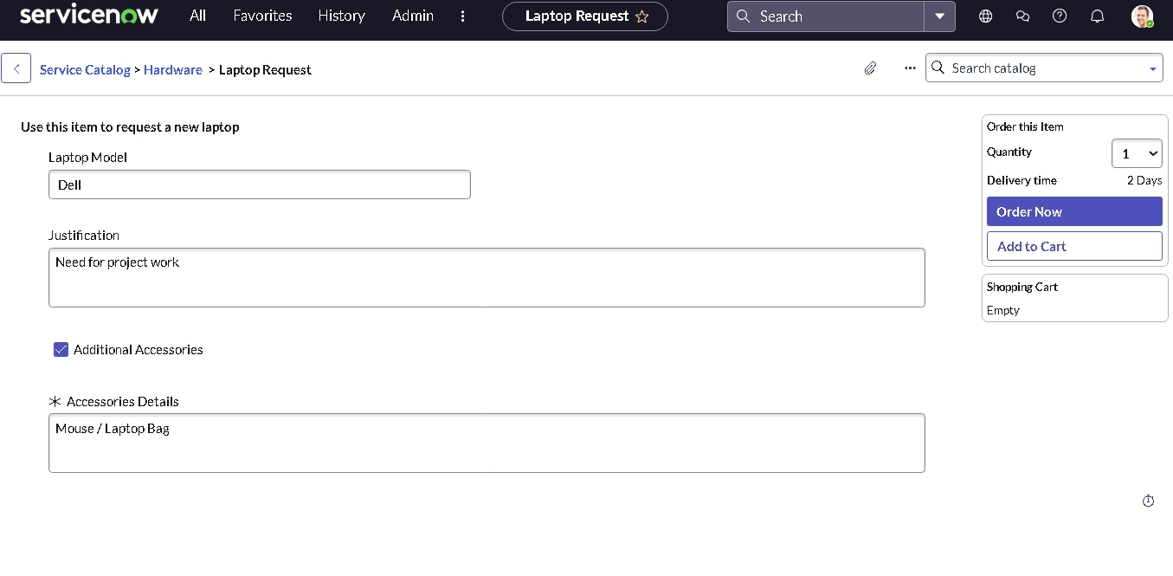

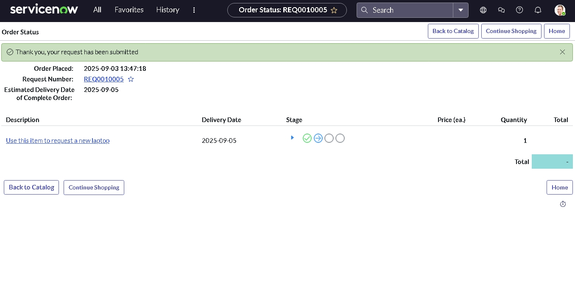

.Project demo link:

<https://drive.google.com/file/d/1-f49JQzY8VcL715broVWM800dBThiqBJ/view?usp=drivesdk>